IGI 2: Covert Strike – international intrigue and extreme action in Russia, Libya and China’s underworld.

May 22nd 2002: Chasing military secrets across Eastern Europe through to the Orient, hacking security terminals, pistol whipping attackers, setting explosives – the IGI team are back and are about to be caught up in their most dangerous assignment to date.
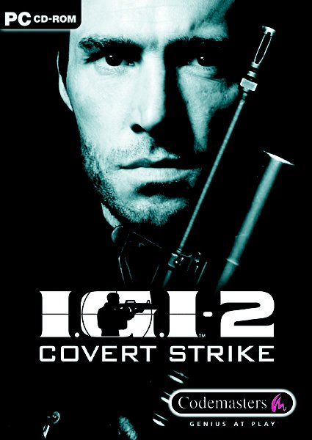

IGI 2: Covert Strike brings the world of Project IGI back to PC screens as the acclaimed stealth-based first-person shooter returns, continuing the espionage theme of the original.

The missions of covert surveillance, stealth and blazing firepower continue the career of David Jones, once a key SAS member, who now works as a freelance operative for a secret organisation code-named ‘IGI’.

IGI 2 is set soon after the events in Project IGI. The Cold War has ended and the Soviet countries are attempting to rebuild their shattered nations. No longer faced with a nuclear stand off, Russia is able to move financial support from its military forces to its private research and production industries. World powers turn their attention to gaining information on each other’s industrial secrets.

The game takes place over three linked campaigns, each packed with individual missions. Each mission expands the plot and is sequenced with impressive animated scenes that draw the player into the game’s carefully constructed narrative. The spiralling plot takes the action through Russia, across Libya and into China utilising locations including military airbases, harbours and secret government installations as a series of objectives are revealed.

Jones’ assignment starts with him plunging into Russia to locate and retrieve any evidence of the rumoured EMP (Electro Magnetic Pulse) chips – new technology which IGI suspect could be employed in weapons development.

It won’t be an easy ride: an advanced Artificial Intelligence system will give Jones’ many enemies the ability to work together as effective teams, using realistic combat tactics and electronic security systems to locate him, hunt him down and neutralise him. The AI will also react in a co-ordinated manner with different characters performing different roles within the team you are opposed to.

Thankfully Jones has all the essential resources to deal with the enemy – whether the task involves intelligence gathering, sniping a guard from a distant tower, or storming a courtyard with all guns blazing. IGI 2: Covert Strike will feature an outstanding array of realistically modelled weaponry in both single and multiplayer modes, from sidearms and machine pistols to assault rifles and rocket launchers. Surveillance and similar modern technology, including a GPS system and light intensified optics, will be featured throughout the locations.

The implementation of a redesigned “Save” system for IGI 2: Covert Strike improves over that of the original game. IGI 2’s Save system is now a function of the map computer – a device which Jones uses to receive tactical support in the field from IGI HQ.

The map computer allows Jones to download and upload – to save and load – the current mission status and position at any time. However, doing so will take time and drains battery energy from the map computer, so players will have to save tactically.

Meanwhile, development work on IGI 2: Covert Strike’s all-new multiplayer mode continues. IGI2: Covert Strike will deliver a full team-oriented multiplayer mode, with squads of eight players per side. With objective-based gameplay, it pits IGI operatives against terrorists from around the globe.

IGI 2: Covert Strike is being developed at Innerloop Studios AS, the Oslo-based team that created the original, and is scheduled to be published* by Codemasters this autumn on PC CD-ROM. The game’s web site and forum can be found at: http://www.codemasters.com/igi2

* World-wide rights excluding Scandinavia

ENDS

UK PRESS INFORMATION

Richard Eddy
Rocket Media
Tel: 0207 437 6100
Email: richard@rocketmedia.co.uk

PRESS RESOURCE WEB SITE
http://www.rocketmedia.co.uk

CODEMASTERS WEB SITE

http://www.codemasters.com

CODEMASTERS CODE M
It’s free to subscribe to Code M, Codemasters’ new privileged subscriber community. Sign up and receive priority access to playable demos, downloads and information ahead of general release. To subscribe, simply click this link: http://www.codemasters.com/codemprogram/joinup.php

CODEMASTERS CORPORATE BROCHURE
The new Codemasters corporate brochure can be downloaded in PDF format by clicking this link: http://www.codemasters.com/corporate/corporate_brochure_090102.pdf

| Notes to Editors:
Codemasters is a leading developer and publisher of best-selling interactive entertainment products for a global audience on current and future gaming platforms and channels. Established in 1986, the company’s dominant brands include Colin McRae Rally, TOCA Touring Cars, LMA Manager, and Operation Flashpoint – a title that has recently featured as a number one best seller across Europe and the USA. The company is the winner of the Queen’s Award For Enterprise in the Innovation category. David Darling, Codemasters’ Chief Executive and co-founder, is the winner of the “Overall Entrepreneur of the Year” award from the UK’s Entrepreneur of The Year 2000. Richard Darling, Design Director and co-founder, is renowned as one of the most prolific game designers in the industry, having been involved in the creation of the company’s staggering 61 number one best sellers. The company is headquartered in Southam, Warwickshire UK and maintains European operations in Germany, France, Spain, and Benelux. The company has its US headquarters in New York and maintains an online gaming facility in Oakhurst, CA. More information about the company and its products is available online at http://www.codemasters.com

